GDD Table Of Contents

1. Design History
2. Game Overview

* Introduction
* Synopsis
* Target Audience
* Target Platform
* Visual Style
* Unique Selling Point

1. Gameplay

* Objective
* Core Game Flow
* Core Mechanics
* Actions
* Interactive Objects
* Economy
* Workers and Stations
* Police Meter
* Computer
* Minigames
* EndGame Conditions

1. Controls + UI

* Camera
* Control Interface
* Head-Up Display (HUD)
* Screen Flow
* Audio, Music, Sound Effects

1. Appendix

* Research References

**=============================================================**

# **Game Overview**

Introduction:

The player is a manager at a shady office, running scams to make a living, hiring people or upgrading the office to earn more money. This ties in with the idle/simulator, earning money to upgrade, then use the upgrades to avoid the police and pay bills.

Synopsis:

After experiencing poverty for most of your childhood, you were taught the ways of a scammer. Will you rise to be the best, or fail and be jailed like all that tried before you.

Target Audience:

* Ages 13+
* Idle RPG/tycoon

Target platform

* Hardware: PC
* Platform: Steam

Visual Style

* 2.5D, top-down, fixed camera view, Minimalistic
* Example: Startup Company & Prison Architect

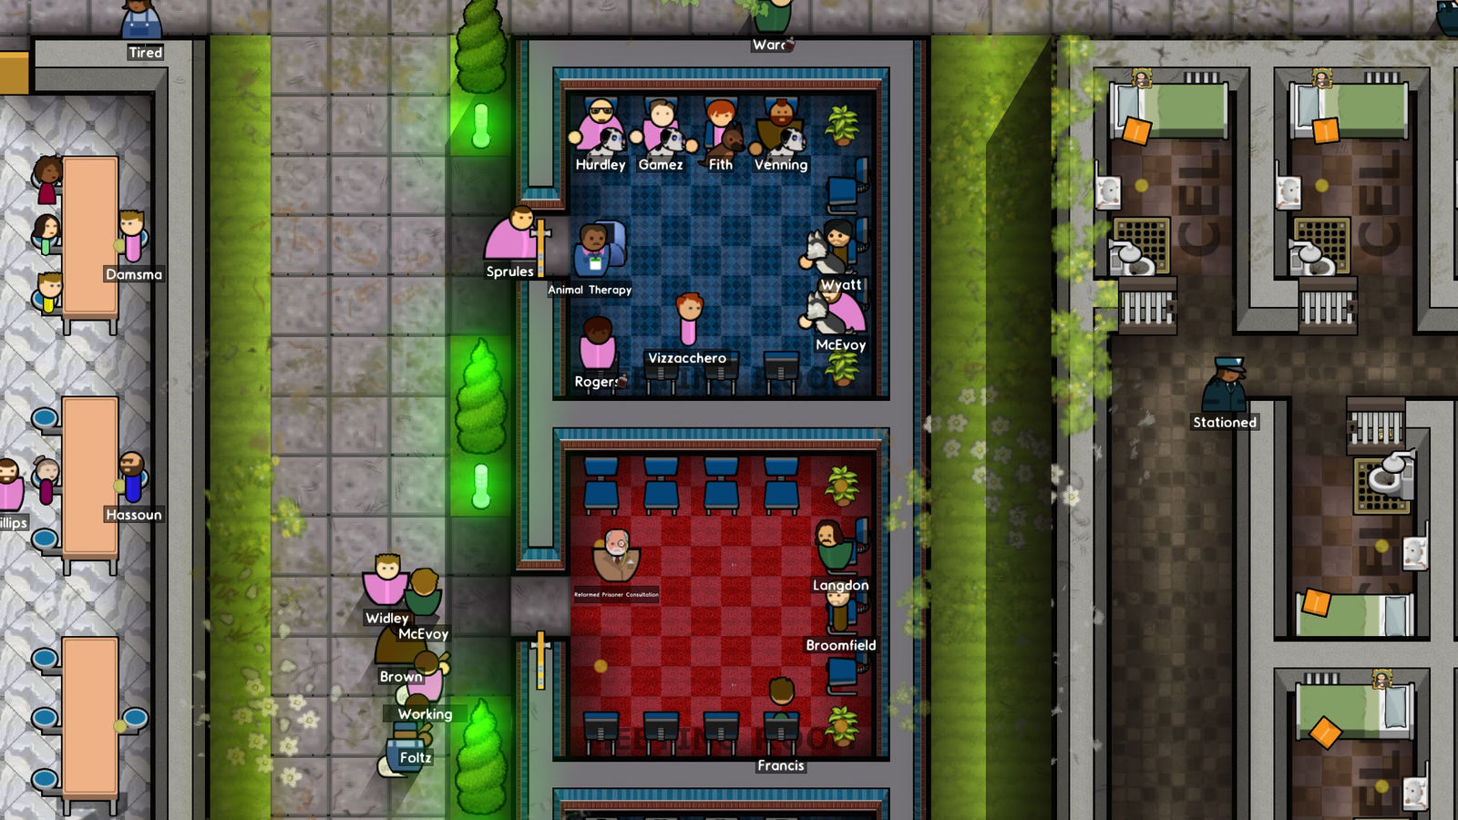

Unique Selling Points

* Risks will have rewards that help the player greatly
* Hiring workers will help you, but also make it more risky to earn money
* Loyal and experienced workers are expensive but worth it
* Bills will increase with more workers or worker levels
* Bribing the police decreases chance of success which makes the police have a higher chance to notice you

**Gameplay**

Objective:

* Earn as much money as possible
* Don’t get caught by the police (Lose Conditon)
* Don’t get bankrupt (Lose Condition)

Core Game Flow: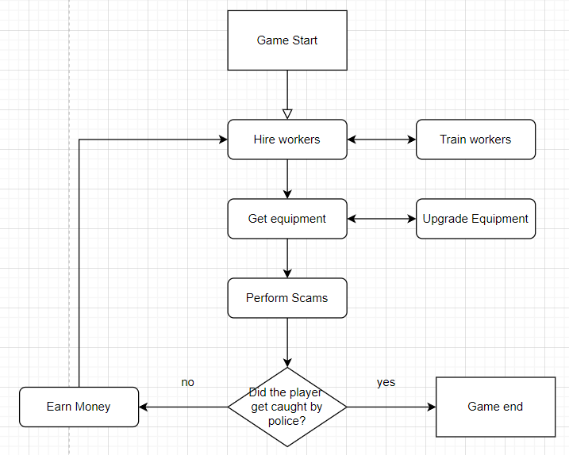

Core Mechanics:

* Upgrading workers and equipment
* Police-Meter(a meter that player has to be aware of, as once the bar reaches its full capacity, the player will be caught by the police)
* Permanent Upgrades (Upgrades that are 1 time purchase)
  + Coffee (increases income)
  + Police deterrent (decreases rate of police meter gain)

- Minigames (For player to earn money or potentially lose money)

Actions:

* Player can control their character with WASD to move around their office
* Player can hire workers and purchase equipment for them at the workstation area, as well as upgrade the workers and their respective equipments
* Player can get permanent upgrades(income increase, police-meter increases at slower rate)
* Player can bribe the police to reduce the police bar and not get caught
* At the PC area, the player can play minigames(Aim Lab-esque game, SMS simulator, Coin Flip or Blackjack) to earn(or lose) money

Interactive Object:

* Worker’s Tables (Buy/Upgrade workers and stations)
* Permanent Upgrade Station (Buying permanent upgrades)
* PC station (Login to PC)

Economy:

* The cost of upgrading workers and computers will increase exponentially, so player will have to continue earning even more money to continue progression
* Cost of buying equipment to decrease police meter increases after each time
* Bills increase with the number of workers and equipments they have
* Bills are incurred every 7 days, workstations + wages (eg. on the 7th day, ignoring days 1-6, if you have 4 noobs, you pay the cost of 4 noobs+workstation. If you have workstation but no worker, you only pay for 3 workstations)

Workers and Stations:

* New Worker is $200
* Upgrade to level 2 is $400
* Upgrade to level 3 is $800
* New Station is $200
* Upgrade to level 2 is $400
* Upgrade to level 3 is $800
* Level 1 worker wage is $40/5 days
* Level 2 worker wage is $60/5 days
* Level 3 worker wage is $80/5 days

Police meter:

* If the police meter hits 100%, the player loses and gets jailed. End game stats will be shown.
* Police meter increases per day(more when you have more workers, 3% per noob, 2% per experienced, 1% per expert), passive reduction upgrade exists.
* Players can ‘bribe’ the police department, which makes the police meter decrease by 50% of the current filled meter. Bribe cost increases by 10% and the success rate falls by 10% after every bribe(successful or not)
* Players can also buy 1 time use equipment to boost chance(10%) of successful bribe(max buy 5 times) or buy equipment to decrease police meter gain by 3%(1 time purchase/permanent, works daily, i.e. total gain-3%/day)(Coffee machine = Police deterrent)

Computer (In player office):

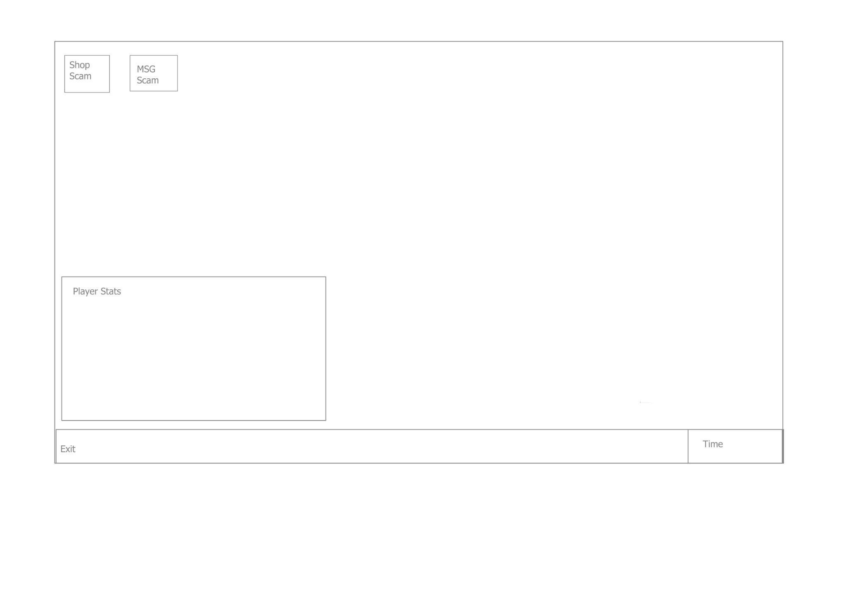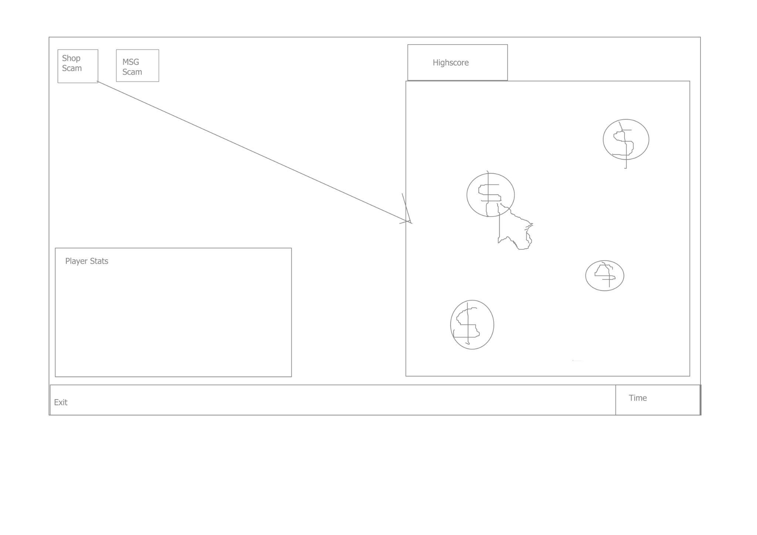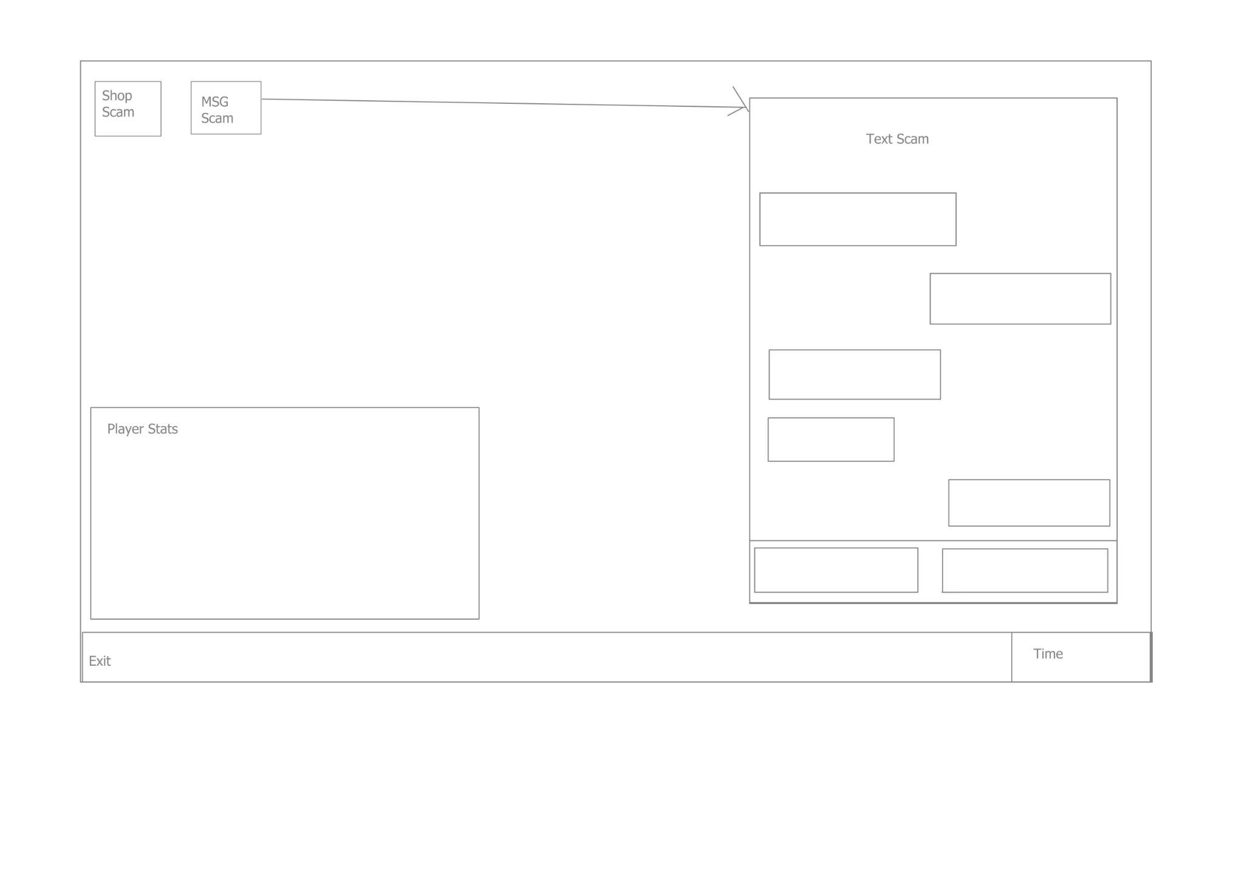

Players can go to a personal computer to or check their income/workers hired as shown in picture 1.

Player can also Play minigames as shown in picture 2 and 3

Picture 2: Shop minigame, Point and click game, the higher the score, the higher the discount for upgrading the items.

Picture 3: Message minigame if player chooses the correct message at least ⅔ times, Player earns some money and will increase police meter by 2% each time. Else player earns no moneys but the police meter will still increase by 2%

Controls: mouse click

Minigames:

Game 1: Players will click coins to earn money. But among the coins will be a red bomb that will cause the player to lose money, and the pc breaks and will be unusable until the day ends.

Game 2: Players will be in a texting app, and they have to give appropriate replies to the messages they get to scam the other party. Each appropriate reply awards money, and the wrong reply will cause the payer to lose monety

Game 3: coin flip, player will have a 50/50 chance to win whenever they flip the coin and will gain or lose a hefty sum

Game 4: blackjack, player pays up front and only receives it back if they tie, and gains double the bet if they win

End Game Conditions:

* Balance is less than 0
* Police meter reaches full

**Camera & UI**

Camera:

Camera will look at scene from fixed top-down and angled view

Camera can move

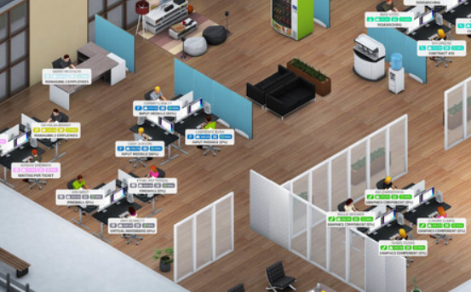Inspired by Startup Company and prison architect

Control Interface:

WASD to control player movement in office

Mouse buttons to select UI items and shop buttons

QERF for other interactions

Heads-Up Display(HUD):

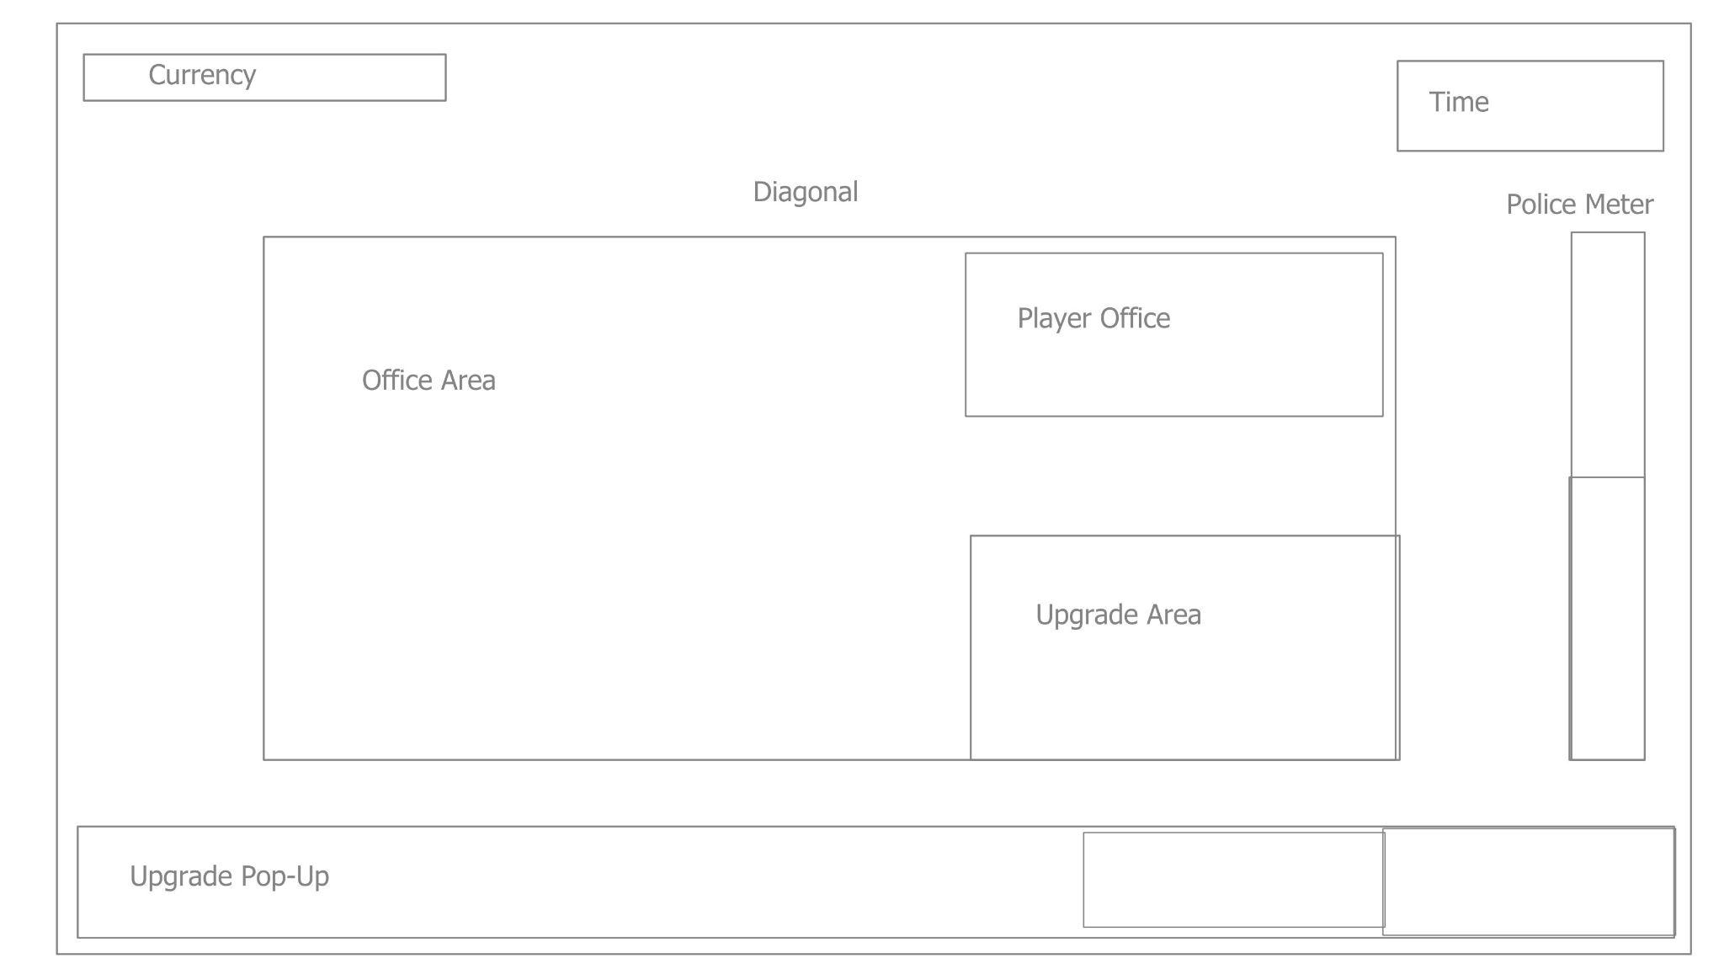

Currency(TL): Amount of money that the player has (Eg. 1200g)

Time(TR): Consists of Day No. and Time (Eg. Day No. 16, 2pm)

Police Meter(R): Meter is dynamic and fills/decreases based on actions, when it fills up completely, you get caught and the game ends.

Upgrade Pop-Up(B): Shows the available upgrades(coloured) and unavailable upgrades(grayed)

Upgrade names will change according to level, cost

Unlock computer

100g

Computer level 1

150g //increase by 50

Computer level 2

250 //increase by 100

If player gold is insufficient, upgrade is grayed out, else it is colored

Text will be black regardless

ScreenFlow:

